Software Requirements Specification

Speed Bump ML

**ــــــــــــــــــــــــــــــــــــــــــــــــــــــــــــــــــــــــــــــــــــــــــــــــــــــــــــــــــــــــــــــــــــــــــــــــــــــــــــــــــــــــــــــــــــــــــــــــــــــــــــــــــــــــــــــــــــــــــــ**

**Table of Contents**

Document Status: 1

Document History: 2

Reference Document: 2

Project Description: 2

Definition: 2

Features: 2

Key elements 2

Software context: 3

SRS Requirements: 3

## Document Status:

|  |  |  |
| --- | --- | --- |
| **Name** | PO_SB_SRS_ML | |
| **Version** | V1.0 | |
| **Status** | proposed | |
| **Author** | SS | |
| **Date** | [13-1-2023] | |
| **Team Approval** |  |  |
| **Mentor Approval** |  |  |
| **Final Approval** |  |  |

## Document History:

|  |  |  |  |
| --- | --- | --- | --- |
| **Version** | **Author** | **Date** | **Change** |
| V1.0 | SS | [13-1-2023] | Initial Creation ,  Adding System context |

## Reference Document:

|  |  |  |  |
| --- | --- | --- | --- |
| **Ref.number** | **Doc.Name** | **Version** | **Status** |
| 1 | PO_SB_CRS_ML | V1.2 | Released |

## Project Description:

### Definition:

A Deep learning model that detects the speed bumps on the road and estimates the distance between the car and the bump.

### Features:

* Model that detects speed bumps on road.
* Estimate the distance between vehicle and bump.

### Key elements

* The deep learning model shall contain algorithms for data mining.
* The deep learning model shall detect speed bumps using neural network
* The distance between the car and the bump shall be estimated.

## Software context:

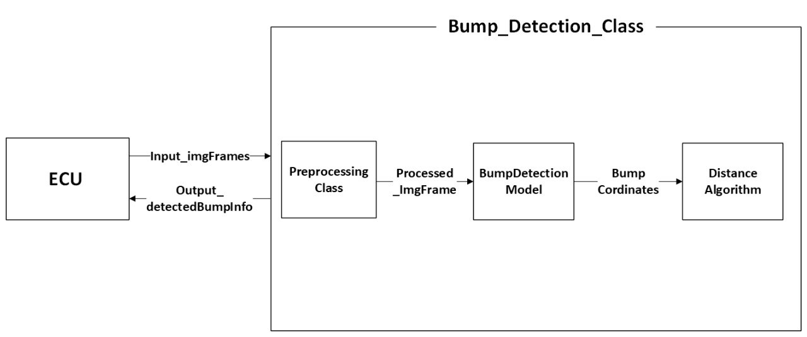

## SRS Requirements:

|  |  |  |  |
| --- | --- | --- | --- |
| **Req_ID** | PO_yyy_SRS_moduleName_**id**-Vx.x Note: where yyy is the project name; the module name is the squares mentioned in the context, like Button_handler that block handle the button functions; | **Covers** | CRS requirement id as it is in the CRS |
| **Description** | For example, In Button handler, SW shall read the input signal “ **BTN1** “ | | |
| **Inputs** | Input name as the context or inner signal | **Outputs** | ----- |